TITLE OF PAPER (style heading 1: font formats - times new roman, 12 pt bold, ALL CAPS; paragraph formats: centered, spacing before 30 pt, spacing after 0 pt, keep with next, KEEP LINES TOGETHER)
PAPER ID (BLANK)

Name Surname¹, Name Surname²
(Style Heading 2: 10pt bold, title case, centered, spacing before 0 pt, spacing after 12 pt, keep with next, keep lines together)
Affiliation¹ (Style Affiliation: 10pt, centered, spacing before 0 pt, after 18 pt, keep with next)
Affiliation² (Style Affiliation; only if affiliation differs; use superscript only if needed)
Abstract (bold). Short abstract (Style Abstract: 9 pt, italic, pt, justified, 0.75 pt left and right indentation).
Key words (bold): key word 1, key word 2... to (max) key word 6, min 4

1. Main Heading (Style Heading 3: Small Caps 10 pt, Centered, Spacing Before 24 pt, Spacing After 6 pt, Keep With Next, Keep Lines Together)
Main text: only use characters and symbols available in the Times New Roman or Symbol font (as in the full text of paper), 10 pt; paragraph format: justified alignment, left and right indent 0 pt, space before and after 0 pt, first line indent 0.5 cm.

1.1. Subheading (Style Heading 4: 10 pt, bold, left, indentation left 5 pt,
spacing before 12 pt, after 6 pt, keep with next, keep lines together)
Sample of main text. Sample of main text. Sample of main text. Sample of main text. Sample of main text. Sample of main text. Sample of main text. Sample of main text. Sample of main text. Sample of main text. Sample of main text. Sample of main text. Sample of main text. Sample of main text. Sample of main text. Sample of main text. Sample of main text. Sample of main text. Sample of main text. Sample of main text. Sample of main text. Sample of main text. Sample of main text. Sample of main text.

1.1.1 Subheading (Style Heading 5: 10 pt, italic, left, indentation left 5 pt,
spacing before 12 pt, after 6pt, keep with next, keep lines together)
Sample of main text. Sample of main text. Sample of main text. Sample of main text. Sample of main text. Sample of main text. Sample of main text. Sample of main text. Sample of main text. Sample of main text. Sample of main text. Sample of main text.

Equations should be prepared using MS Equation Editor 3.0 (insert… object) as a part of MS Word, with styles and sizes as defined in Fig. 2. On the other hand, the authors should avoid using MS Equation Editor directly in the text (e.g. when they explain quantities used in the equations) and symbols () should be used instead. Only if no adequate symbols are available, MS Equation Editor is to be used directly in the text.
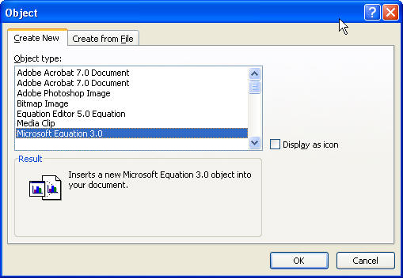
Fig. 1 Title of figure
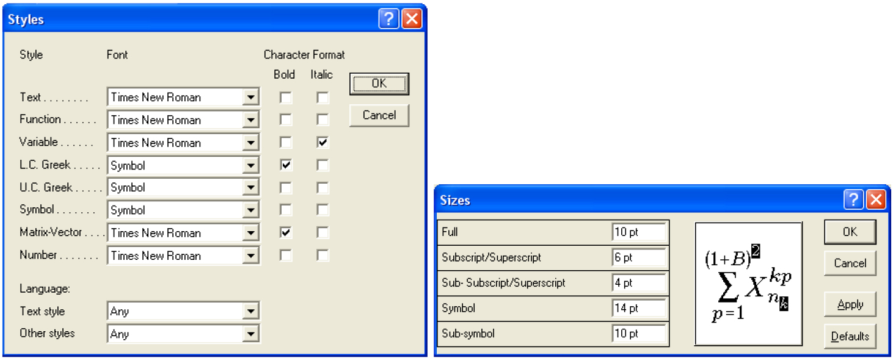
Fig. 2 Styles and sizes for equations
As an exception, if MS Equation Editor 3.0 is not available in the Word version used by authors, i.e. MathType Equation Editor is installed, then MathType Equation Editor can be used.
An example of equation written in MS Equation Editor 3.0:
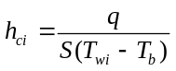 (1)
Paragraph format for equations are (Style Equation): left indentation, 6 pt before and after, equation is at position of centered tab at 6.25 cm, number of equation is at position of right tab at 12.7 cm. See Eq. (1).

Illustrations: figures, photographs, line drawings, graphs
(Styles Figure and Figure Title)
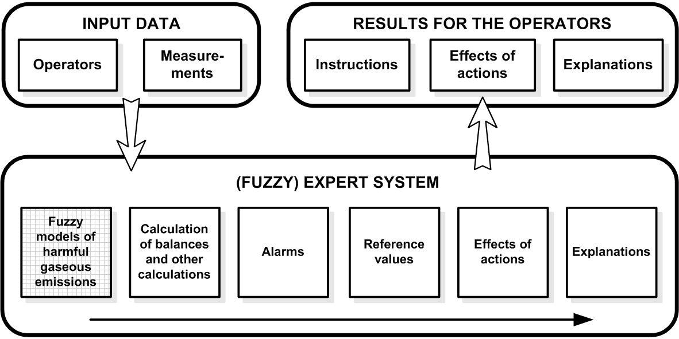
Fig. 3 Title of figure
All illustrations (figures, photographs, line drawings, graphs) should be numbered in series and all legends should be included at the bottom of each illustration. All figures, photographs, line drawings and graphs, prepared in electronic form, should be converted in TIFF or JPG (max quality) files, in 300 dpi resolution, for superior reproduction. Figures, line drawings and graphs prepared using elements of MS Drawing or MS Graph must be converted in form of pictures and unchangeable. All illustrations should be planned in advance so as to allow reduction to 12.75 cm in column width. Please review all illustrations to ensure that they are readable.

Tables
Table 1 Title of table (Style Table title)
System | Symbol
Without delay | +
Delay h = 1 | −
Delay h = N = 34 | *
All tables should be numbered with consecutive Arabic numbers. They should have descriptive captions at the top of each table and should be mentioned in the text.
Acknowledgement: The paper is a part of the research done within the project 1234567890. The authors would like to thank to the... (Style Acknowledgement).

References
(Samples for Serial, Book, Proceeding, Thesis, Report - Style Reference)
- Blagojević, V., Milosavljević, Č., 2002, Application of digital sliding modes to synchronization of the work of two pneumatic cylinders, Facta Univesitatis Series Mechanical Engineering, 1(9), pp. 1275-1285.
- Stojiljković, M., 2002, Logical synthesis of pneumatic control, Faculty of Mechanical Engineering, Niš, 376 p.
- Muralidhara, H.S., 1998, Variable structure systems - A Survey, Proc. Sixth International Drying Symposium IDS 1988, Versailles, K1. 71.
- Polat, O., 1989, Optimization of a Steam boiler, PhD Thesis, McGill University, Canada, 413 p.
- Perkin, R.M., 1999, Feature models in Virtual Product Development, Report ECRC/M1677, Capenhurst, England.

